## AIMS data Extract

* Open AIMS URL and login

[AIMS - WebUtil (alshaya.com)](http://apps.alshaya.com:7777/forms/frmservlet?config=aims)

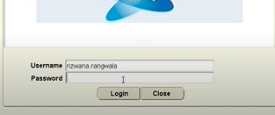

* Click on ‘Ok’ button if below pop-up appears

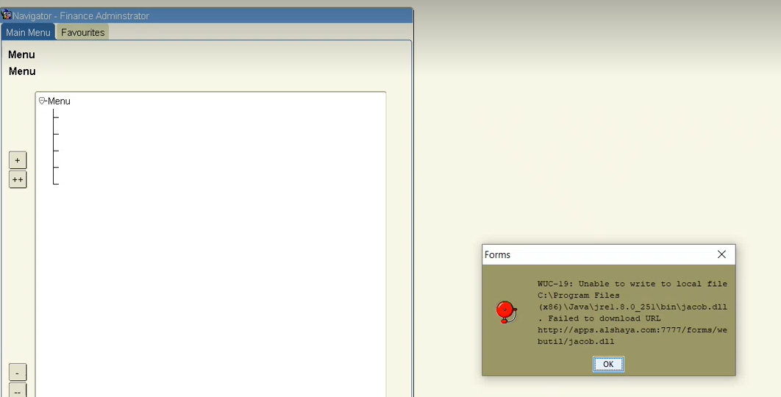

* Click on this icon

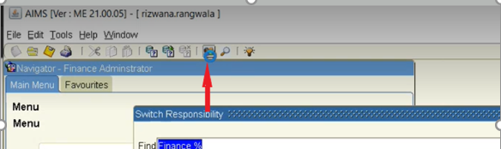

* Select ‘Finance Miscellaneous Income’ Responsibility and click on ‘Ok’ button

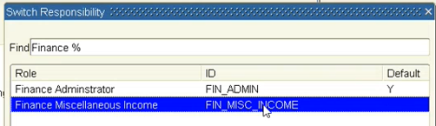

* Select ‘Misc Invoice Summary’

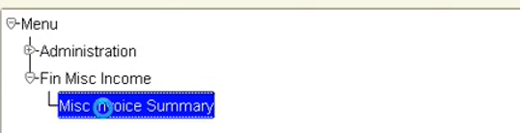

* Click on 3 dots and select ‘All Brands’ from the list

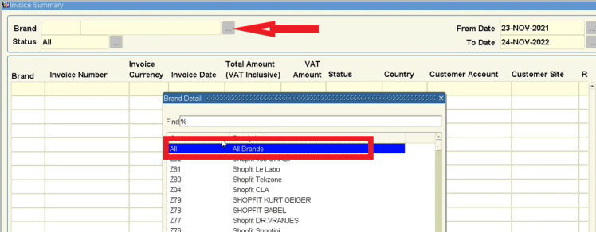

* Update the fields and click on ‘Extract’ button. Press CTRL+S and the pop-up window will appear. Click ‘Ok’ button

|  |  |  |
| --- | --- | --- |
| **Field name** | **Condition** | **Comments** |
| From date | During 1st half of the month, from date is (Sys date – 15)  During 2nd half of the month, from date is 1st day of current month | On 2nd Dec, BOT to select 17th Nov  On 16th Dec, BOT to select 1st Dec |
| To date | Sys date | On 16th Dec, BOT to select 16th Dec |

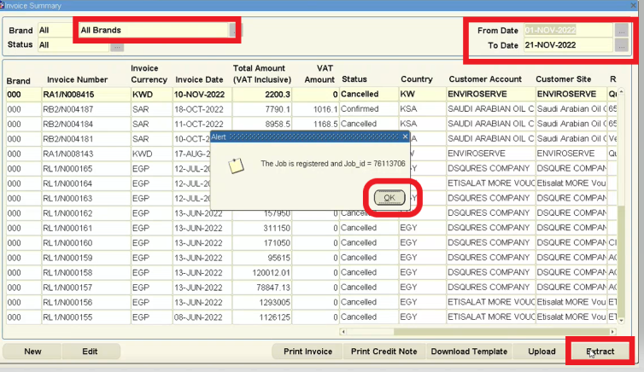

* Close the above window, Go to Administration --> Job Control

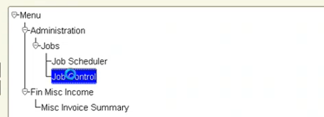

* Click on ‘Refresh’ button

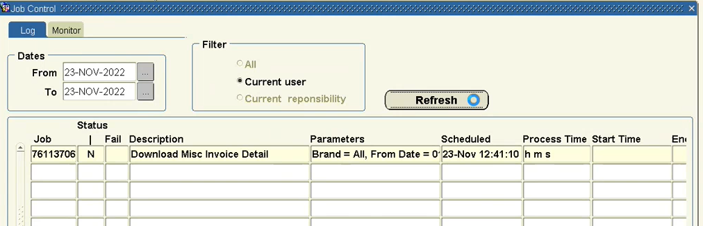

* Wait until the data is getting exported in excel format like below

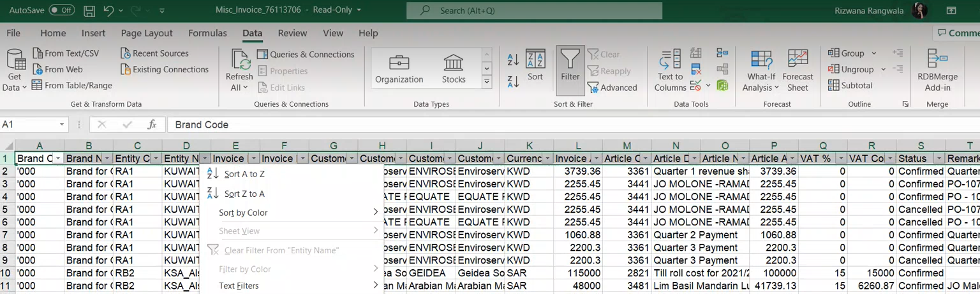

7Name the file as **‘AIMS Reco Dec 22.xlsx’** and name the sheet as **‘AIMS data’**

* Extract has data for all markets and brands. Take In-scope market details from ‘VAT%’ sheet in mapping file Check if VAT% (Col Q) given in the dump is correct for all markets based on ‘Entity Code’ in the extract

## AIMS Reconciliation

* In **‘AIMS Reco Dec 22.xlsx’** file, create a sheet and name it as **‘Oracle data’**. Open **‘Oracle Wholesales data_Dec 22.xlsx’** file, copy the whole data and paste it in ‘Oracle data’ sheet like below

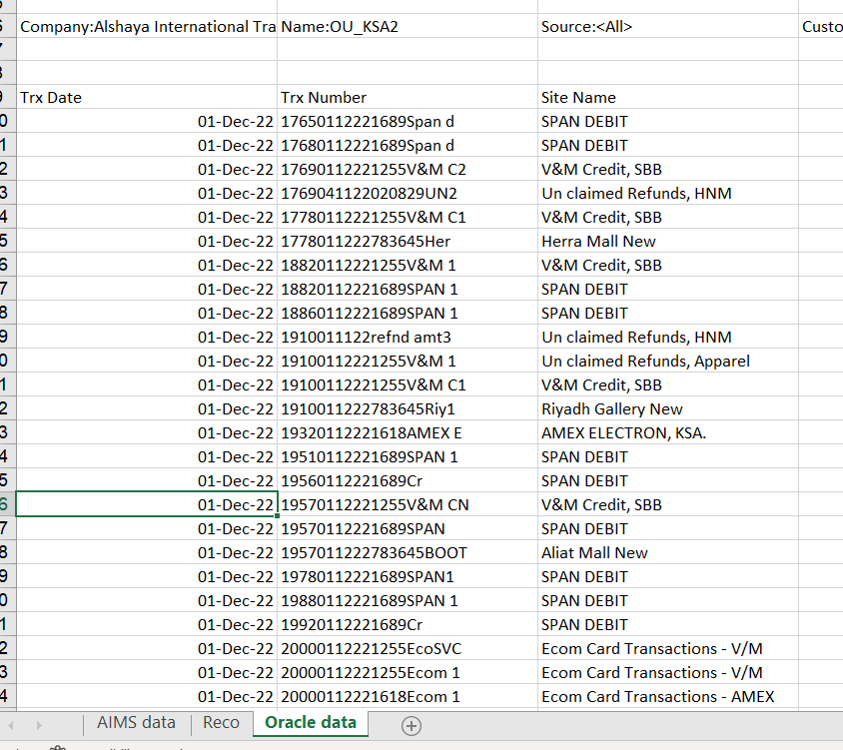

* Create one more sheet, name it as **‘Reco’** and create columns as instructed below:

|  |  |  |
| --- | --- | --- |
| **Column** | **Header Name** | **Condition** |
| Column A | Entity Code | Comes from ‘AIMS data’ sheet (Col C). Only In-scope Entity data should be pulled to Reco sheet |
| Column B | Invoice Number | Comes from ‘AIMS data’ sheet (Col E) |
| Column C | Entity Name | Comes from ‘AIMS data’ sheet (Col D) |
| Column C | Invoice Amount | Comes from ‘AIMS data’ sheet (Col L) |
| Column D | Total Amt in Oracle | Comes from ‘Oracle data’ sheet (Col E) |
| Column E | Variance | Diff b/w revenue from 2 sources.  i.e. Invoice Amt in AIMS– Total Amt in Oracle |
| Column F | Status | To be filled by BOT |

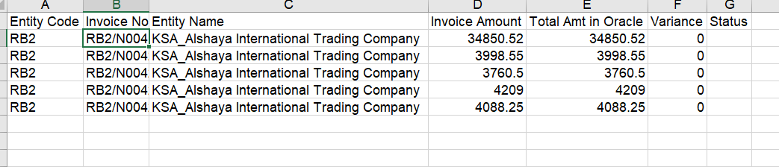

* In ‘Reco’ sheet, Oracle amount should be pulled by matching Invoice number Col ‘B’ with ‘Trx Number’ in ‘Oracle’ sheet.
* If variance > or < 0, update the status as ‘Business Exception’ in Column ‘F’ in ‘Reco’ sheet
* Save the file and share it with business
* Today, only KSA, UAE, Bahrain and Kuwait markets are in-scope. As in-scope markets are likely to increase in future, a provision is created in mapping file to generate report only for the markets which are called as ‘In-Scope’ in mapping file. Refer ‘Yes’ (Col F) in in-scope sheet in mapping file.